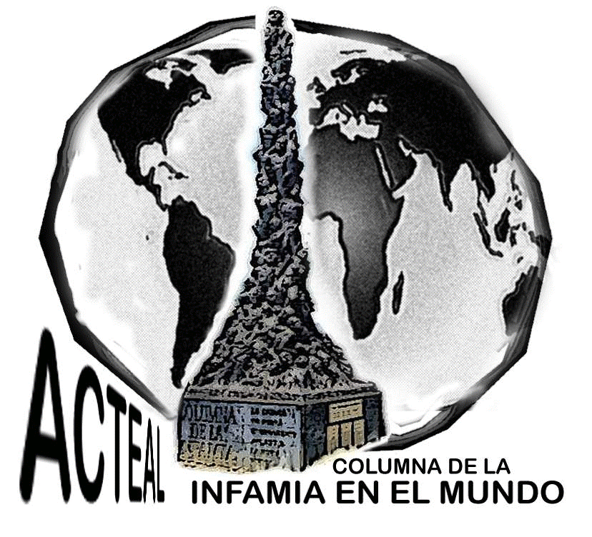
Civil Society Organisation “Las Abejas”
Sacred Land of the Martyrs of Acteal
Chiapas. México.

8th March 2013.

To the public
To the media, local, national and international
To alternative media
To the sixth international
To the adhesives of La Otra Campaña
To the independent organisations
To the nongovernmental human rights defenders

Brothers and Sisters,
Welcome to the ceremonial centre of the martyrs of Acteal. We would like to thanks everyone for your participation in this International Women's day march

Today the 8th of March, we the women of Las Abejas are gathered to remember our sisters who were murdered here in Acteal in 1997. The majority of those who were murdered were women and children. After our sisters had passed away some of the pregnant women had their stomachs cut open and their babies ripped out. We are survivors; we bring our happiness, the massacre cause terrible sadness and sickness. Today is also a reminder that there was no respect for the women in the United States who were fighting for their right to a fair wage.

The slaughter of our sisters by the Mexican government, is an act that demonstrates the rejection of women's rights, we do not want that to happen, we want peace and justice.

Our martyr sisters were gathered to create our organization, they spoke the truth, and they were brave and gave their lives so that we could move forward. They went hungry; they were not frightened by threats. If they were here today they would support our fight and even though they are not with us physically we know they are watching over us.

The paramilitaries have returned, again we ask them to leave our communities as we did years ago. They are here in our communities drinking, getting paid, getting land provided to them but the corrupt government, living in large houses and enjoying the privileges the government provides them.

We don't understand why others accept money from the government. Why is it important to look wealthy? And the martyrs of Acteal, where are they now? We know they will never return but we remember how valuable they were to us. The government continues to suck the life out of us, we have had enough of the injustice, enough of the corruption!
We the women of Ch'enalvo 'invite our sisters to join us: do not be afraid to speak the truth, do not be afraid to denounce the governments abuse, their attempts to blind people with their lies and destroy the strength of Las Abejas and prevent us from protesting or speaking out against them.
As the women of Las Abejas we speak of good, not evil, we speak the truthfully about what is happening in our communities and the journey of our organisation. We speak out about the wrong doings of the government and we share our struggle.
The massacre of Acteal opened many hearts, and has increased awareness in villages, cities and around the world about the injustices here. The government has allowed the introduction and sale of alcohol in our communities which has lead to an increase of violence against women. We say ENOUGH, to the alcohol! Not only does it result in violence against women it also puts our families in debt, leaves our children hungry. Now our young people drinking and disrespecting their families.
So we say to all those who have not yet gathered together to speak out against their husbands who mistreat them, we want you to know that as a woman you have rights and your husband and families need to understand what your rights are.
We are working together to demand justice, we know that the government will continue to try and crush our efforts but we will continue in our resistance!
We would like to thanks you all for participating in this march for International Women's Day. We ask that all our brothers here today support your wives to come and work with us in our fight for justice.

